Operations Management Fall 2018

Assignment 10
Instructions:
a) Show all the steps followed to arrive at the answer.

1. Solve the Problem B.3,

Solve the following linear programming problem graphically:
Maximize profit = X + 10Y
Subject to: 4X + 3Y ≤ 36
2X + 4Y ≤ 40
Y ≥3
X, Y ≥ P
- 4X+3Y≤36 if x=0 then y=12
X=9 then y=0
- 2X+4Y≤40 if X=0 then Y=10
X=20 then Y=0
- y≥3
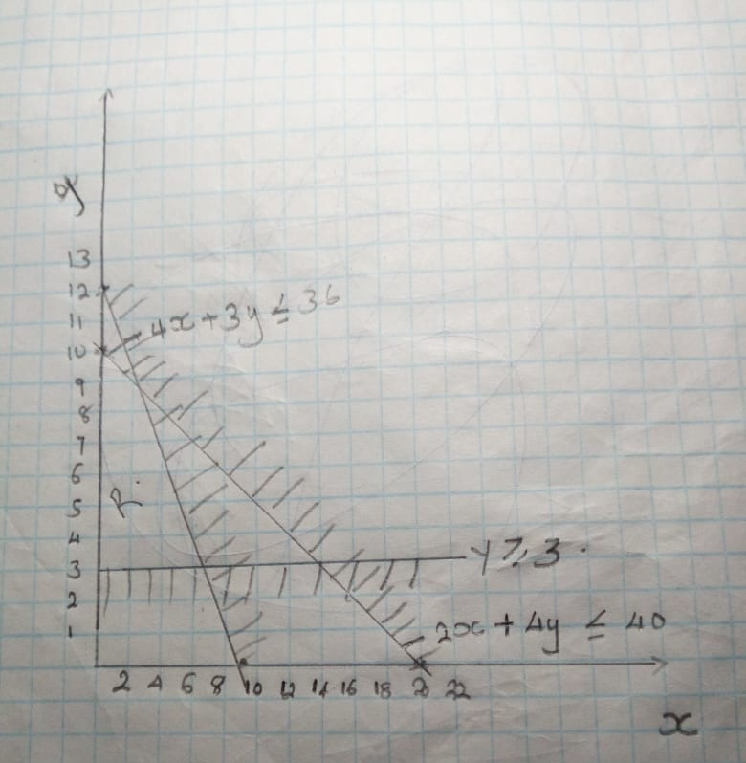
Maximizing profit= X+10Y
To maximize profit we take the highest value of Y and X which is
X=7 and Y= 10
Therefore the maximum profit will be
=7+10(10)
=107
The maximum profit is 107

Question B5

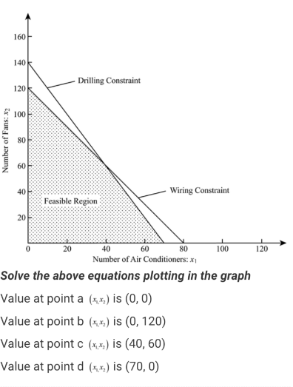
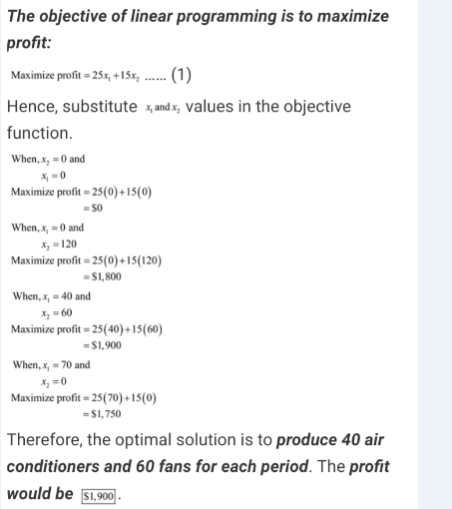

Question B7

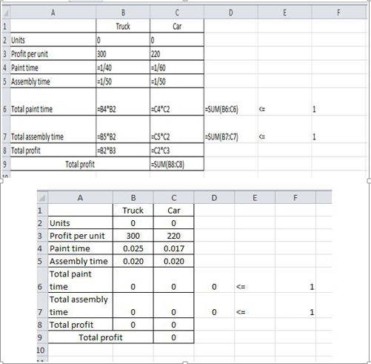

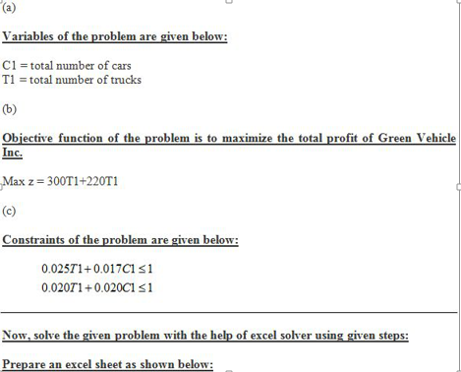

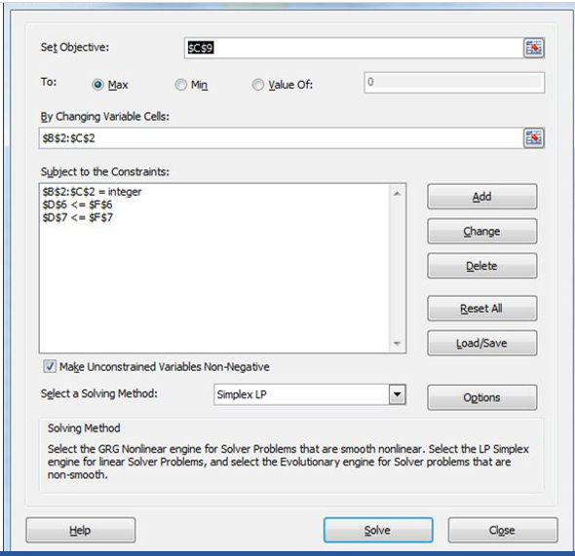

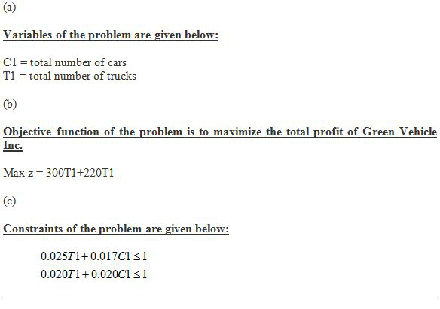
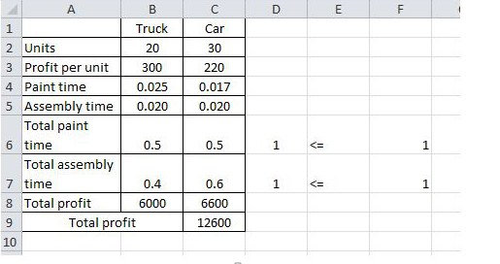
It us determined that the maximum profit realized by the company is $12,600
And in order for the company to meet its goals it has to manufacture 30 units of car and 20 units of trucks.

Question B.11
Substitute 8 for X₁ and X₂
=9X₁ + 12X₂
= 9(8)+12 (2)
=96
This means to maximize profit of 96 it is key to produce 8 coffee tables and 2 bookcase.

Constraint A
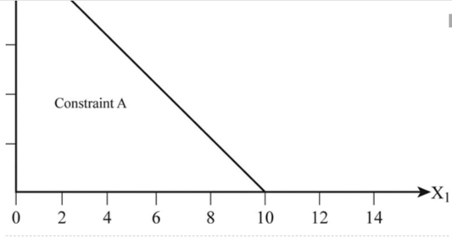

Constraint B
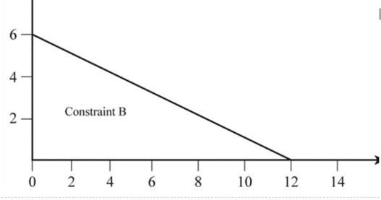
Intersection
